# Lab 6



**Spring 2023**

**Submitted by:**

**Maaz Habib**

**Registration no:**

**20Pwcse1952**

“On my honor, as a student of University of Engineering and Technology Peshawar, I have neither nor received unauthorized assistance on this academic work”

**Submitted to:**

**Engr: Muhammad Usman**

# LAB 6

**BCD to Seven Segment Decoder**

**Objective:** To implement a BCD to Seven Segment Decoder on S3BOARD.

**Block Diagram:**

In This lab you are required to take a BCD input from the user and display that number on the seven segment display. Following diagram shows the 7 bit code for displaying “2” on the seven segment display all the input are active low signals. Note that enable signal should be held low in order to turn on the particular seven segment display. There are 4 seven segment displays on the S3BOARD. In later labs you will learn how to use time multiplexing techniques to turn on all the four seven segment displays as the input A,B,C,D,E,F,G, Dp are shared by all the four seven segment displays.

**Lab Task: 1**

- Using switches enter a BCD number and show the resulting number on the seven segment display.

2- Connect the output of your lab assignment 1 S0-S4 to the seven segment display. Note that number above 1001 are not valid BCD numbers. In this situation keep the seven segment display off and just the dp on



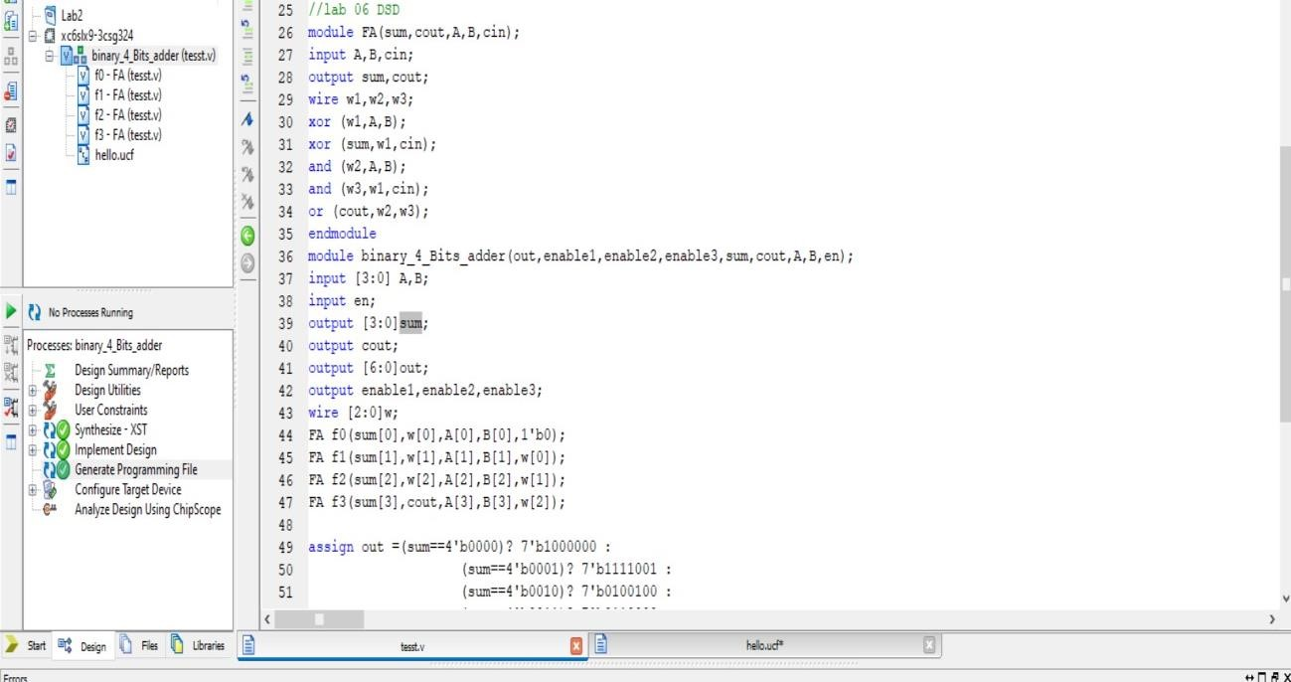

**UCF:**

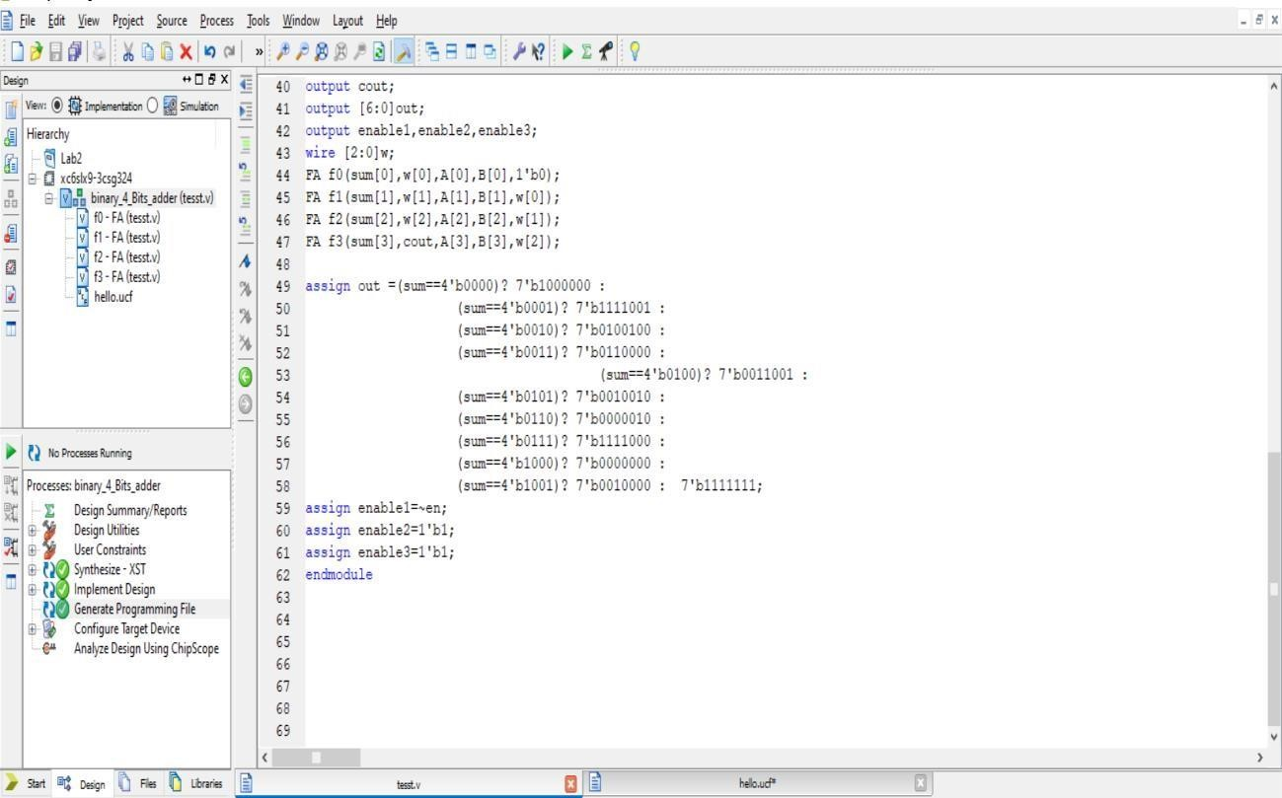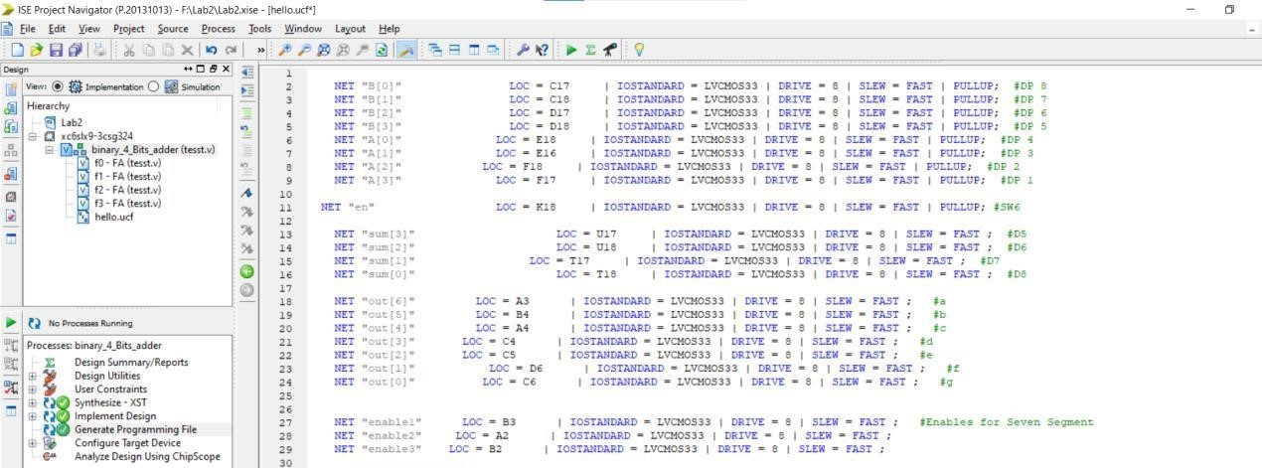

**Output:**

Pin 5,6,7 and 8 are input pins and pin 1 is enable pin. Pin 6 and 8 are set to 1 while pin 7 is set to 0 I,e (101==5 in decimal).

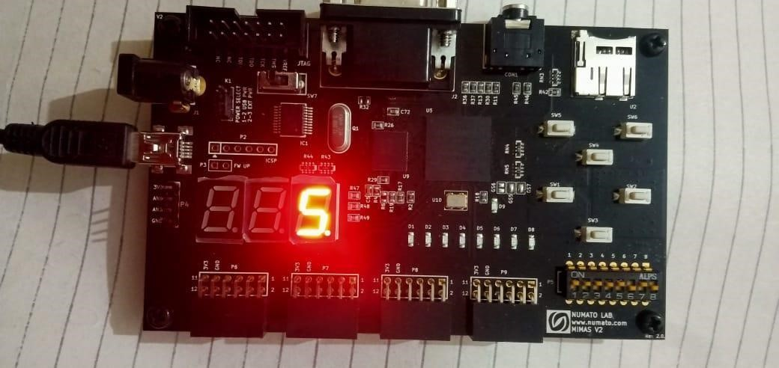

In this picture invalid input 1100 which is not BCD input so no led on.

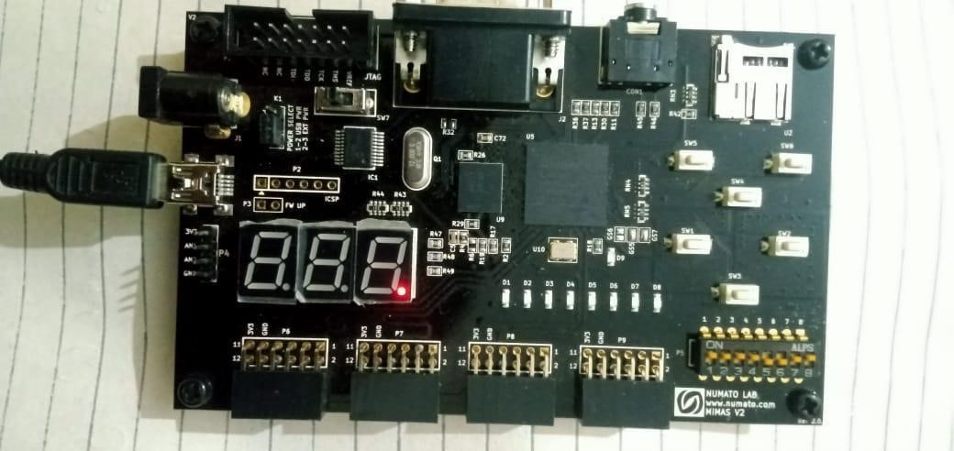

In this picture Enable input (dip switch 1) is set to 1 so while enable input is active low input so the circuit becomes disable.